2025 Fishing the Sipp Fishing Rules
Bass species (Black Bass)-Largemouth, spotted, smallmouth
This will be a CPR tournament (Catch, Photo, Release)
Available Waters to Fish-Any public water in the State of MS or where Mississippi fishing licenses are reciprocated by TN and AL in Pickwick Lake.
Rules:
- Must launch from a public boat ramp.
- Everyone in the vessel must always wear a lifejacket (at all times while on water)
- Kayaks are allowed to have a motor on them
- All vessels must have the proper registration
- Youth must have a fishing license if youth are of age (16 or older)
- If youth are caught cheating, it will be an immediate DQ
- All state and local fishing and boating laws must be followed
ANYONE WHO IS FISHING IN A BOAT OR KAYAK MUST WEAR A LIFEJACKET AT ALL TIMES NO EXCEPTIONS
IF YOUTH FISH OUT OF A KAYAK, YOUTH MUST HAVE A WHISTLE ON BOARD
All fish will be judged off length. To judge them, you will lay the fish across the board and take a picture. See attached picture for example. Fish facing left and dorsal fin facing up with closed mouth up against the board with tournament identifier present in picture.
It will be a 5 fish limit and we will take the cumulative total of the 3 largest fish you submit, in the case of a tie, the person with the single largest fish will win.
Ways to fish:
- Boat- All ages Must have an adult to captain the boat
- Kayak-Must be 4-H age Senior (14 on January 1) to fish alone
- Bank Fishing-all ages
Prizes will be awarded for 1st, 2nd, and 3rd, as well as largest bass in the Jr. 4-Her and Sr. 4-Her category.
Youth will be given a unique Identifier on the Morning of October 1st by email. The identifier will have to be in the picture when they take the picture of the fish. It can be on the board, written on your hand, or laid next to the board. See photos for examples.
All fish must be caught on public water, the app used will gps tag where the photo was taken, only the tournament director can see this, no one else.
If 2 fish look similar with similar markings, the Tournament Director will be notified, and fish will be reviewed. This could be fish from the same or different people fishing together.
It is recommended that you use a Ketch Board or Hawg Trough measuring board as these are ¼ boards such as the one shown in the picture below.

Rules for submitting plot:
- Your hand must not cover the eye (To show that the fish is alive).
- Your hand must not touch the Caudal (tail fin) also known as pinching and holding the tail.
- Mouth must be closed and against board, it will be a ¼” deduction if mouth open at all.
- ½” deduction or a DQ (if continues to happen) will occur if hand covers where the mouth touches the board.
- The fish must be facing left and dorsal fin must be facing up like in the pictures.
- Identifier must be in the picture when taken.
- Fish must be touching the bump part of the board like in the photo.
- No fish grips or lures are allowed in the fish’s mouth when you are taking a photo.
- If your board only measures in ½” the fish will be rounded down, A board that has ¼” marks is recommended.

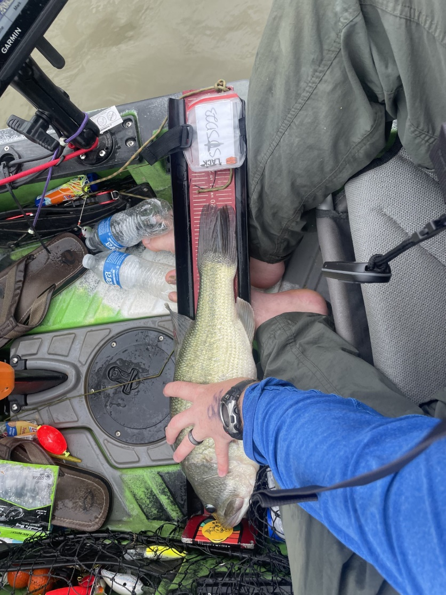
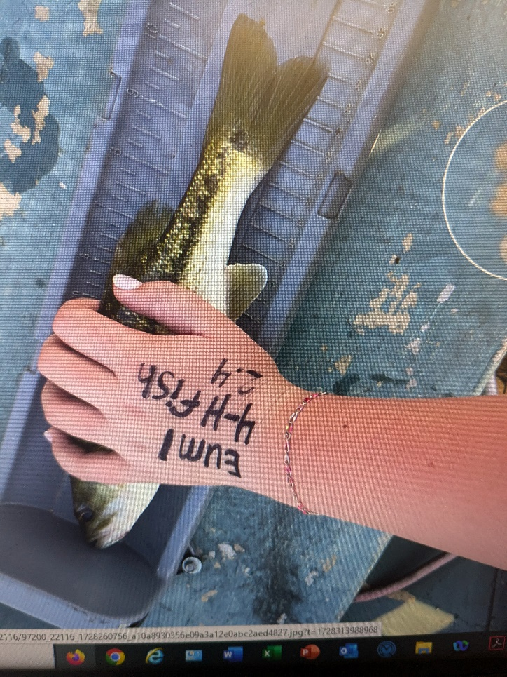
Example of identifier for photo to enter into Tourney X app.

