Social Media is free and other advertising myths
How to make social media a part of your overall marketing plan.
Karen S. Stanley

Every day there are new social media platforms announcing they are the best way to reach your current customer base. How do you choose which one is the best option for you to invest your time and money?
In the past, deciding how to spend your marketing dollars felt easier. Traditional media advertising had a cost associated and we decided how best to spend those dollars because we knew someone was listening on the other end. Right? They are waiting to hear about the next big thing we have going on. We saw or heard our ad so we knew it must be working, right? Heck, even our friends told us they saw our ad and loved it so it must have been working. Now suddenly you are doing what you have always done and it just doesn’t feel the same. What has changed?
The way society makes decisions, gathers news and interacts with brands and businesses has dramatically changed in the past few years. So when your gut begins telling you your advertising dollars do not seem to be helping you as much as they used to, you should listen. Maybe you have already started a few social media accounts. That’s a good thing. If all you have done, however, is start them and have not remained active on them, you are shooting yourself in the foot.
Almost every day a new hot social media channel is announced. Then, on the flip side, a new article is released declaring the social media channel you are using is dead. How do you make sense of it all? First, ask what social media channel are my customers using? Second, ask exactly who is my customer? If you are stumped by either of those questions, then this article is here to help you.

Define your social media audience
Many businesses are often hard pushed to define who their customers really are. They may be able to call a few by name that are “regular customers” but on average, defining exactly who is interested in what they are selling is a challenge.

Start with the Easy Stuff: Demographics
Take a moment and let’s define some of the regular characteristics of your customer. Our goal at the end of these questions is to define these key demographics: age, gender, location, income level, occupation, marital/family status, ethnicity, and education level.
- How expensive is it to attend your upcoming event or ongoing activity? Do your customers/attendees need to fall into a certain income class to afford your tourism option?
- Is your event or ongoing community promotion specifically for men or women? If either, think about who typically attends. What is their typical age? Are they married? Do they have a family? Who makes the attendance decisions?
- Where is your target attendee physically located? Are they local? In the neighboring town? Do they come from specific areas of the country; have specific interests or other unique qualities in common?
Once you have defined your customer in a way that you know better who they are, you will be better equipped in deciding which social media platform to embrace. You’ll also be able to make better decisions in traditional advertising for a more robust and effective marketing strategy.

Be picky choosing the right networks for you
Be honest. How many social media accounts do you currently have for your business or organization? Do you have two, three, four different accounts on one social media channel? Or maybe even zero? Wherever you are in your social media adventure, I advise you to take a moment and evaluate each and every one and how often you are posting on them.
Even though signing up for social media accounts does not cost you a thing, treating them as if they are unimportant can cause you to lose ground with both existing customers and future customers (more on that later). Here are a few tips to help you make sure you are handling your social media effectively:
- Now that you know who your customer is, (from defining them in our demographics section) are they on the social media platforms you are currently using? Also, do you have the resources to maintain each of the platforms you are currently participating on? Yes, signup is free, but your time and your staff’s time being invested in keeping social media active is a very valuable resource.
- Have you signed up for every social media channel because they were new or popular? Take a moment at the end of this and really evaluate (and possibly cancel) some of those accounts based on how you plan to move forward. We would rather you be amazing at one or two channels than mediocre at five or six.
- Have you made a plan to use your social media channels? Is it clear and will you or someone else be in charge of keeping it updated? We want you to manage your social media, not the other way around. Stay focused on your business and don’t let social media rule your day.
- Don’t get frustrated and give up on your plan to fast. Just like any good business, time and effort are invested prior to success. You must sustain a plan for a period of time to truly see your efforts become successful.
As you struggle to decide which of the social media channels you should be using, keep your demographics in mind as well as use this fun graphic created by Carlos Monteiro based on research from the Pew Research Center. Specifically notice the rural interaction with social media.

2015’s most popular & effective social channels
As we discussed at the beginning of this article, social media is ever-changing. The social media channels we discuss in this document may not be the social media channels that we would recommend for your specific business but they are some of the most utilized channels in today’s social media environment.

Facebook
Facebook, by far, is the biggest of all social media networks today. With 1.44 billion users monthly and 65% of those using the platform daily², Facebook is the most utilized social media in the world – meaning more of your customers are here waiting for you. If you choose only one social media network to become involved with, this one is the no brainer. This medium is also one of the easiest to target exactly whom it is you would like to “talk” to when you make your posts as well as target with strategic and very affordable advertising.
However, this page must be updated at the very least one time per day. A balance of promotional material as well as engaging and interesting content must be produced. We encourage all of our clients to make a 70/30 mix to their posts. Seventy percent should be engaging and interesting material, with only 30% promotional material. It does need a decent amount of human and financial (advertising) capital invested to make your business successful on this platform.
Advertising on Facebook can be extremely affordable. Promoted posts are an affordable way to make sure your target market is seeing what is happening in your community or venue. Be strategic and make sure when choosing the audience you want to promote your material to that you are very specific in remembering the demographics we discussed at the beginning of this paper. With Facebook ads you will be able to see how many people were exposed to your ad as well as who “liked” and interacted with the information.

Twitter
Twitter also remains one of the key players most often mentioned in social media. It is a good way to reach a younger, tech-savvy crowd and has 302 million monthly users³. In this medium, information reigns supreme! Posts on Twitter should be timely and look to reach the crowd currently on the platform. Within 18 minutes your post will have reached its peak⁴ and the information shared will become buried in the constant flow of information available at the time to the viewers. It is a wonderful tool to also connect with like-minded or employed individuals within your field. Rural Tourism happens in all corners of our country and learning from others and connecting with them can be a powerful way to gather knowledge that helps you in your day-to-day business. Sponsored posts can be effective to allow your information to have a longer life.

Google+
Anything Google related has to be good, right? One of the bonuses of this network is that it does increase your SEO (search engine optimization) because Google+ is Google. It is often portrayed as a ghost town but has 300 million active users a month⁵ and with new additions like Hangouts, 1+s and the use of hashtags it has become a social media that is somewhat a blend of Facebook and Twitter.
Activity is key on this account and you must update it on a regular basis. If your business has a Google+ page, when someone searches for your business your most recent posts will be displayed to him or her in a very prominent way in their search results.

Pinterest
Do you have lots of great visual content you can share? Do you market primarily to women? This may be a network you should consider. With 85% women and 72.8 million monthly users⁶, Pinterest burst onto the social media horizon and blew up in what seemed like an overnight success.
Tourism is a perfect fit for this venue. Whether you are a Downtown area and want to encourage people to visit your local merchants, or a community attempting to connect with locals as well as visitors this can be a space to share what makes you unique. Consider making boards (this is how you group your images in a cohesive manner on this network) that include local history, green spaces, faces of our community, places to stay, etc.
Plan to spend some time setting up your posts so they easily link back to your website, social media page or even have links to purchase tickets to upcoming events. Promoted Pins should be available to business pages soon, according to the Pinterest website⁷. These will allow you to choose the right people you want to see your pin.

Instagram
Yet another popular app that deals in sharing photographs, Instagram makes everyone feel like they are an amazing photographer as you point and shoot with your phone. Popularizing adding filters to photos, Instagram can help you make the picture of a lovely tree you have in your downtown community feel like a photo from Ansel Adams. (Well, maybe not exactly, but close enough on your smart phone screen.)
With more than 300 million users⁸, advertisers are now slowly being able to promote their photos in ways very similar to Facebook. For a bit over a year Instagram has been running carefully curated ads with large major retailers. Although currently every Instagram account is not able to advertise yet, Instagram has shared that targeting will be very similar to how ads are targeted through Facebook ads. With a current user base being split almost 50/50 between males and females⁹, this opens the opportunity to use a purely visual platform that is popular with both sexes.

LinkedIn
LinkedIn is the largest social media site geared toward business professionals today. Often times it is forgotten that this is a place where you, as tourism experts, should be connecting and sharing news about your industry and about what is happening in your communities. There are more than 350 million users¹⁰ and 2.7 million business pages¹¹.
The approach to this page, both as a business page and as a business professional, is more serious in nature than some social media, although humor does have its place. This is a wonderful place to connect with other rural tourism experts as well as join “LinkedIn Groups” where industry professionals continuously share tips and research that will be pertinent to tourism or whatever interest that group provides. You can post job openings, volunteer needs, promote events that have CE (Continuing Education) hours associated with them, make business contacts and also establish yourself as an industry expert. Advertising can be somewhat pricy on this site but using many of the features are free.

YouTube
Videos are king on social media and the web in general. The first social media site to be incredibly successful at filling our screens with cat videos, how-to videos and things we used to have to wait for Bob Saget to show is YouTube. Despite the websites Vine, Twitter and Facebook, YouTube remains the most popular video site on the web with 1 billion users and 4 billion views per day.¹²
As you consider YouTube, keep in mind that a huge factor to choosing to be active on this site is the fact that it is the second largest search engine after Google (sorry Yahoo and Bing!)¹³. Optimizing (paying for) ads that promotes your content and amazing videos here can make a serious impact on your campaigns. You also may not know that YouTube is owned by Google, so when it comes to enhancing your SEO (Search Engine Optimization) rankings, videos rank over 50 times more likely to appear on the first page of search engine results.¹⁴
If you have produced (not necessarily shot with your phone) videos that are exciting and visitors will enjoy sharing, this may be a good fit for your marketing plan. However, as you compete with the ever-growing video information uploaded on YouTube, over 100 hours are uploaded every minute¹⁵, the videos you promote and produce will primarily need to be professionally executed to stand out from the competition. Make sure you consider the human resources and potential cost in creating this content prior to signing your organization up for an account.

Websites, Blogs and Niche Social Media
There is no way to cover every social media option available today in this paper. As you choose which mediums are best for you to use, first explore the bigger names in social media. Then, and only if you know you’ll have time to maintain them, consider the smaller, niche platforms.
Presence on the internet should always include having a website that you have access to maintain and edit yourself or with your staff. Working in tourism, your website should show what is actively happening in your venue and community. If your website does not easily allow you to make those kinds of changes yourself, it is time to make decisions about how to get this corrected. Social media should always lead people back to a website where they can choose to dig and find more information about your offerings.
Blogs are another way to reach your customers. Easily shared through your different social media platforms, this is a simple way to communicate information in a longer format than is recommended for any social media post. These updates can be done regularly and you may find you have many consumers who are interested in knowing more about your business and prefer this type of update. You can also welcome guest bloggers from your community to share their thoughts in this format. `

Content
In the past few years an evolution of sorts has taken place between social media and content marketing. Blogging, infographics, and short form videos are all relatively new formats of interacting with your customers. Along with these new ways to communicate through content marketing you must find the right social media to best reach your audience and you must determine what content you have to share.
What content do you already have in your arsenal to use?
- Written – This is obviously the most flexible content type and is a cornerstone of most social media efforts. Your words become the voice of your business, so be selective in how you communicate to your customers. While content can always be considered king, often the brevity of what you say and how you say it are just as important in getting your message across. Twitter may have invented the 140 character rule, but with human attention spans dwindling to less than that of a goldfish¹⁶, be careful in over speaking.
- Video – The use of video in social media has truly exploded recently. There is a wide range of ways to use video for tourism. How-to videos, quick tours of businesses in your communities, site tours to entice potential visitors to come and experience your community, or behind the scenes snippets as you prepare for your upcoming event. If your budget allows you to invest in a good point and shoot video camera or even a professional videographer, by all means do this. However, do not let that stop you from making fun segments with the powerful tool you possess in your smart phone.
- Visual – Visual content reigns supreme in every form of social media. There are networks that are exclusively made to handle creatively crafted photos. Take time to dig back through older, printed images and scan those on your social media platforms. There is warmth to old visuals being used in new ways. A picture speaks a thousand words and can make it very easy to get your point across.
Jason DeMers at Search Engine Land created this great infographic below breaking down social networks into seven different types. Each has their own characteristics.
- Kitchen-sink networks: Twitter and Facebook
- Image-based networks: Pinterest, Instagram, Tumblr
- Video networks: YouTube, Vimeo, Vine
- Business-focused networks: LinkedIn
- SEO and authorship networks: Google+
- Location-based networks: Foursquare, Yelp
- Niche networks: reddit

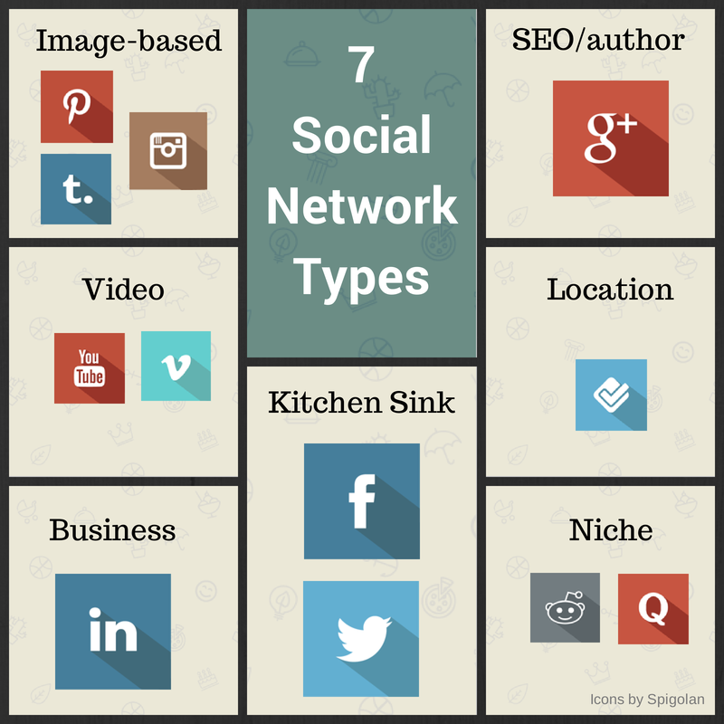¹⁷
Is this list complete? Absolutely not. This is just a good visual way to look at some of the options out in the world of social media.

but don’t millennials hate social media
First let’s go back to determining if millennials are your target demographic. If they are then, yes, let’s pay attention to this first generation that has spent their entire lives around technology. They live their lives always wired in. They have a keen awareness to your digital communication and have some secrets we should look at for tourism. In a recent article, Laci Texter of Social Media Week wrote about their insights¹⁸:
- Experiences are worth paying for. The experience of anyone with an upcoming trip, event attendance, etc. always starts prior to them actually making it to the place they ultimately want to be. With millions of places they can go and spend their time, they often research and observe information about these decisions before they ever get there. Make sure you are sharing regular info on why people should choose your venue or community. They really are listening and want to hear from you.
- Word of mouth trumps fancy ads. Creating beautiful ads and content is incredibly important, but nothing is more important than creating engaging social media and having regular people talking about you. It is a useful investment, both in time and money, to provide them with content that is easy to share, especially when they are ready to share it.
- The 4-year plan is finished. In the rapidly changing economy, being flexible and nimble is the name of the game. While always staying true to the brand you have built over the years, when an opportunity exists to discuss current events and how they directly correlate with you, just do it! If business in your downtown sells amazing, small batch dark chocolate, and the news has just released a story that dark chocolate is good for your health, post about how they are doing their part to keep your community healthy. Have a plan of how you will handle your social media but never be afraid to tweak it when something you did not see coming presents itself.
- Weak ties perform better than strong ones. Having a large number of weak ties to a brand or event (noticing a large number of friends RSVP’ing to an event on Facebook) is even stronger than having a small number of strong ties (a close friend recommending you attend an event). People can be like cattle: they move in the direction the vast majority of the herd is going.
- Digital loves Old School. The fact that #ThrowbackThursday is widely known on every form of social media should be our first clue. Nostalgia, memories from our childhood, reminders of events or people that put smiles on our face are home runs in every form of social media. So dig through those VHS tapes of old commercials, share old photos and items you have found in dusty corners that harken to a pre-digital era. You have gold in those forgotten photo albums and out dated tools of days gone past…use them!
- Buzzwords are out. Social media moves fast and what is “cool” today can change at a moment’s notice. Stay away from trying to speak in a language you do not understand for fear of alienating the natives that are using it. Your outcome will not be groovy or awesome unless you speak like a down to earth real person in a casual manner.

A few things you should NOT do on social media
Most businesses are guilty of committing these social media crimes at some point. No matter where you are in your social media experience, be it a novice or an expert, take these tips as ways to save face in the world of social media.
- Don’t treat social media as your marketing slave. Social media is exactly what its name says – social. If every day your posts are 100% sales related you will lose the followers you have gained. You must be polite, interesting, responsive and most of all human. Try to have about a 70/30 mix with only 30% of the time directly talking about selling something. The beauty of working in tourism is you are selling an experience, which is much more subtly conveyed by showing how others are enjoying their experiences with you. Talk to your customers and have a relationship with them. If all you want to do is sell, sell, sell, don’t be surprised when they leave, leave, leave.
- Don’t create a business profile or page and then abandon it. In tourism it would be nice to control every aspect of what happens in your community. However the harsh reality is, you can’t. There will always be that business that doesn’t take care of their lot or trash situation and has become an eyesore. Social media is the same way. Finding a company business page and getting excited as you want to connect with them only to find out their last post was in 2012 is disheartening and you then become that social media eyesore. If it is not working for you, or if you do not have the time or staff to handle the medium, it is better not to be there than to leave an abandoned page. Shut it down, delete it and reopen it only if you know you have time and have a plan to manage it.
- #Aggressively #overuse #hashtags. Sure they are fun and can make you feel cool but they also scream, “I am advertising to you!” One or two can be a fun addition to your post but every post should not be hash tagged 30 times.
- Over posting. We get it. You are excited about what you have going on, or maybe you feel like you are making up for some time when you didn’t post. Rarely should you post more than 1-2 times in a single day (an exception to this rule can be Twitter as the life of a post in this medium is much more finite). Only break this rule if you have an event going on and are posting as the event occurs. If uploading multiple photos at one time, make sure you know how to upload items in a photo album format.
- Don’t connect all of your social media channels together. Almost every social media channel has a way to easily post to every other social media channel you have. Think about this from your follower’s perspective. If I follow you on Facebook, Twitter, Instagram, and LinkedIn, then I am not excited to see you posted the same information by pressing one button. Each post should be tailored to the medium you are interacting with and posted at the most optimal time. This will never work as you share material across mediums. Oh, and as your follower, I am now editing you out of my feed on several of these sites since you are not interested in engaging with me with different, original content on each one. The exception to this is if your company is in a crisis communication situation and you are trying to share information that is vitally important to all of your followers.
- Not spell checking. Marketers and social media administrators joke all of the time that if you want to see how many people are actually reading what you put out on social media, misspell something! We are not advising you do this but we do encourage you to misspell as little as humanly possible. Mistakes happen, when they do, apologize and fix the problem.
- Attempt not to argue with customers on social media. Social media can be a double-edged sword in many people’s opinion. It gives you an amazing opportunity to have personal dialogues with your customers. It also gives unhappy customers a platform on which to air their grievances in a very public way. If at all possible, take these discussions off of the main page and move them to private or direct messaging. Often, these critiques can be a wonderful opportunity to correct a wrong that you may not have even realized happened. Always attempt to solve these issues. Deleting or ignoring a comment can enrage a customer. Engage with them and attempting to fix or at least address whatever issue they may have.
- Remember the number of likes, follows, etc. are not the only way to determine if your social media is successful. When you follow a big brand, like Krispy Kreme Doughnuts, you may be shocked to learn they have over 4.8 million followers on Facebook. You look back at your 300 “likes” on Facebook and feel like your number should be bigger. Remember the market for your business. You do not want people following you that will never truly be your customer. Having fans that interact and respond to what you are posting is the most important part of social media. Having them halfway across the country and not interested in ever actually visiting your location does not help your bottom line nor should it make you excited to have more followers.
- Do not use your business page to share personal information. There are times and places that sharing personal information on your social media page is appropriate, but they are rare. Remember, as you post on your business page you are serving as your brand. Try to keep those types of posts limited to your personal page. Also keep in mind though that what you post on your personal page, especially in smaller markets, will most likely also be seen as a reflection of your business.
- Bad timing for social posts. Most administrators of social media accounts will use scheduling tools to help us control and optimize posting times for future posts. However, some of those posts may appear in bad taste. As a rule, I encourage social media managers to always be in tune with what is happening in the national and local media. During the recent Boston Marathon bombing, most social media channels chose to go dark for what they considered a respectful amount of time and shared only that their prayers and thoughts were with those affected by the tragedy. Never attempt to capitalize on a tragedy. It is better to be respectful and honest during times of tragedy.

Conclusion
Social Media is the DIY Communications style that can be a marketing dream. It should be a part of your marketing plan and budget but not the only marketing your business embraces. Tourism is a wonderful medium to use this tool and interact both with locals and travelers as they are looking for something to do in your community. There are software applications and tools that can help you automate your postings and help track what others are saying about your business. Outsourcing is also an option if you do not have the internal staff to handle this medium for you.
If you take anything away from this paper I hope it is to see that there is not a “one size fits all” solution to social media for any business. Take your time as you craft your plan and struture how you will move forward with your media. Success and satisfaction can come from this form of advertising for your business. We will leave you with this fun graphic that purr-fectly explains how social media can used in your business.
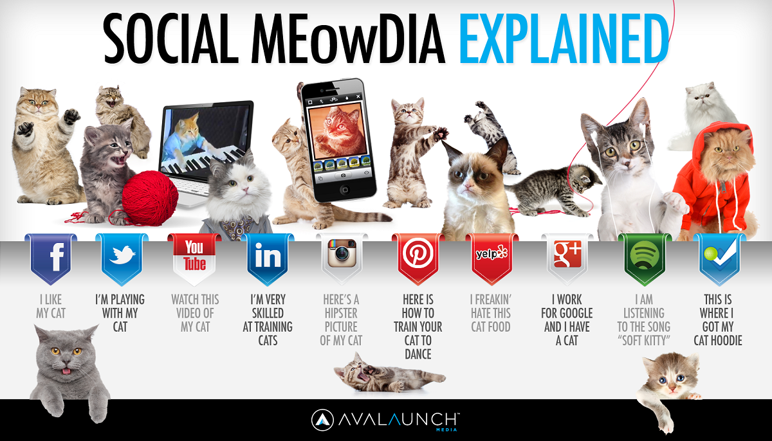
Image courtesy Avalaunch Media¹⁹

References
¹Moses, Lucia (2013, March 6). Blacks and Hispanics Are More Likely Than Whites to Use
Twitter Graphic breakdown from Pew by age, gender, race. Retrieved from http://www.adweek.com/news/technology/blacks-and-hispanics-are-more-likely-whites-use-twitter-147666
²Smith, Craig (2015, June 7). By the Numbers: 200+ Amazing Facebook User Statistics
(June 2015) Retrieved from http://expandedramblings.com/index.php/by-the-numbers-17-amazing-facebook-stats/
³Smith, Craig (2015, June 17). How Many People Use 800+of the Top Social Networks, Apps
and Digital Services? Retrieved from http://expandedramblings.com/index.php/resource-how-many-people-use-the-top-social-media/7/
⁴Lee, Kevin (2014, August 21). How to Choose the Right Social Network for Your Business.
Retrieved from https://blog.bufferapp.com/how-to-choose-a-social-network
⁵Smith, Craig (2015, June 17). How Many People Use 800+of the Top Social Networks, Apps
and Digital Services? Retrieved from http://expandedramblings.com/index.php/resource-how-many-people-use-the-top-social-media/3/
⁶Smith, Craig (2015, May 23). By the Numbers: 90+ Amazing Pinterest Statistics. Retrieved
from http://expandedramblings.com/index.php/pinterest-stats/
⁷Pinterest Help Center (n.d.) How to Promote a Pin. Retrieved from
https://help.pinterest.com/en/articles/how-to-promote-a-pin
⁸ Smith, Craig (2015, June 17). How Many People Use 800+of the Top Social Networks, Apps
and Digital Services? Retrieved from http://expandedramblings.com/index.php/resource-how-many-people-use-the-top-social-media/4/
⁹Smith, Craig (2015, June 6). By The Numbers: 140+ Interesting Instagram Statistics.
Retrieved from http://expandedramblings.com/index.php/important-instagram-stats/
¹⁰Smith, Craig (2015, June 17). How Many People Use 800+of the Top Social Networks, Apps
and Digital Services? Retrieved from http://expandedramblings.com/index.php/resource-how-many-people-use-the-top-social-media/4/
¹¹Bendror, Yasmin (n.d.) Which Social Media Channels Should I Use For My Business?
Retrieved from http://smallbusiness.yahoo.com/advisor/social-media-channels-business-223554094.html
¹²Smith, Craig (2015, June 17). How Many People Use 800+of the Top Social Networks, Apps
and Digital Services? Retrieved from http://expandedramblings.com/index.php/resource-how-many-people-use-the-top-social-media/9/
¹³Bendror, Yasmin (n.d.) Which Social Media Channels Should I Use For My Business?
Retrieved from http://smallbusiness.yahoo.com/advisor/social-media-channels-business-223554094.html
¹⁴de Valk, Joost (2013, April 8) Why you’re probably missing a chance in search with video.
Retrieved from https://econsultancy.com/blog/62476-why-you-re-probably-missing-a-chance-in-search-with-video-2
¹⁵Bendror, Yasmin (n.d.) Which Social Media Channels Should I Use For My Business?
Retrieved from http://smallbusiness.yahoo.com/advisor/social-media-channels-business-223554094.html
¹⁶Qualman, Erik [equalman]. (2015, January 26) Social Media Revolution 2015
#Socialnomics. [Video File]. Retrieved from https://www.youtube.com/watch?v=jottDMuLesU
¹⁷Lee, Kevin (2014, August 21). How to Choose the Right Social Network for Your Business.
Retrieved from https://blog.bufferapp.com/how-to-choose-a-social-network
¹⁸Texter, Laci (2015, June 17). 6 Things Millennials Know About Brand Communications
That You Don’t. Retrieved from http://socialmediaweek.org/blog/2015/06/6-things-millennials-know-brand-communications-dont/
¹⁹Siltala, Matt (2013, February 22) Social Meowdia Explained. Retrieved from
http://avalaunchmedia.com/infographics/social-meowdia-explained

