**2019 State 4-H Congress Handbook**



*4-H: Inspires Youth to Think*

State 4-H Congress

May 29–31, 2019

**THE WHAT, WHEN, WHERE, WHY, AND HOW OF STATE 4-H CONGRESS**

**WHAT Is State 4-H Congress?**

**State 4-H Congress** is an annual state event designed to supplement our county 4-H programs. This event provides positive leadership and educational opportunities for senior 4-H members from across the state in an effort to develop these young people to their full potential to become productive citizens and catalysts for positive change to meet the needs of a diverse and changing society.

2019 State 4-H Congress officially begins on Wednesday morning, May 29, 2019 and ends Friday morning, May 31, 2019. The ***official delegation*** is made up of 4-H members, 4-H registered volunteer adult leaders, and extension agents/staff registered for the event. It is expected that all counties will be represented. The annual event takes place on the campus of Mississippi State University.

**WHY Attend State 4-H Congress?**

The major purpose of State 4-H Congress is to:

* perpetuate the reputation of 4-H as a major statewide educational program;
* improve delegates’ knowledge and skills through practical learning experiences, life skills training, and leadership development opportunities;
* provide opportunities for delegates to participate in the democratic process through campaigning for and election of State 4-H Council Officers;
* provide recreational and social experiences for delegates;
* select winners in competitive state events; and
* provide recognition for project work and competitive accomplishments.

**WHO Attends State 4-H Congress?**

**YOUTH DELEGATES**

Any 4-H member between the ages of 14 and 19★ is eligible to attend 4-H Congress for the following activities:

* Visual Presentations, Judging, and Miscellaneous Contests
* State 4-H Ambassador Activities
* Candidates for State 4-H Council Offices
* Workshops

★A 4-H’er must be fourteen (14) years old on **January 1, 2019** and must not have had his/her nineteenth birthday by **January 1, 2019**.

**REGISTRATION IS REQUIRED!**

Registration will be done via an online registration system that is available at the county level. All delegates, i.e. 4-H members and registered 4-H volunteers and staff, must be enrolled in the enrollment system to come to Congress.

**Congress Registration Opens: April 1, 2019**

**Congress Early Bird Registration and Full payment closes on May 1, 2019 and regular registrations closes on May 10, 2019.**

Checks should be made payable to MSU-ES/4-H for the total amount due. Mail checks to the State 4-H Office, attention Courtney Headley, Administrative Assistant, 4-H Youth Development Box 9641 Mississippi State, MS 39762.

* **Reminder:** MSU Extension Agent’s registration fees will be paid by Center Heads in each Region.

**Early Bird Registration: April 1–May 1, 2019**

* **$120.00 per person (includes 2-nights lodging and a $40.00 meal card)**
* **$80.00 person (lodging/no meal card)**
* **$90.00 per person (no lodging/meal card)**
* **$55.00 per person (no lodging/no meal card)**

**Registration after Early Bird: May 2–10, 2019**

* **$130.00 per person (includes 2-nights lodging**

**and a $40.00 meal card)**

* **$90.00 person (lodging/no meal card)**
* **$100.00 per person (no lodging/meal card)**
* **$65.00 per person (no lodging/no meal card**

**NOTE:** The registration and state council fees are used to pay for lodging, meal cards, T-Shirts, DJ, insurance, facilities use, equipment, and other related charges. If a meal card is lost, a replacement meal card will not be available. ***Remember, it is important that the 4-H delegates budget carefully to make the $40 meal card last throughout the entire event.***

Registration fees will not be adjusted or refunded after May 10, 2019**,** except in cases of extreme emergency such as illness or death. These cases will be reviewed individually upon receipt of a written request addressed to Dr. Paula Threadgill.

**STATE 4-H COUNCIL DUES**

Each county will be assessed $5.00 to cover State 4-H Council dues. This must be paid before county delegates can vote. This fee is automatically added to your county fees.

**EARLY ARRIVALS**

Early arrivals may check in on Tuesday, May 28, 2019 from 5:00 pm until 7:00 pm in the Bost Extension Center Building B. Early check-in registration is designed for counties that will be coming early and need housing on Tuesday night. If this applies to your county, please register for three (3) nights lodging, total cost $135 unless paid after May 1st ($145). **Please note on your hard copy registration form that you will be arriving early**.

The State 4-H Ambassadors will also be arriving on **Tuesday, May 28, 2019** for orientation activities. They will need to check in on Tuesday and receive their housing assignment(s). *The* ***State* 4-H Ambassadors** *and their chaperones (****one per gender****) must be registered on the online registration program. If housing is needed for Tuesday night, please register for this. The additional cost will be waived as it is paid by the State 4-H Department.*

**CHECK IN FOR STATE 4-H CONGRESS**

Official check in for State 4-H Congress will take place in the lobby of **(TBA)** on Wednesday, May 29 from 8:30 am to 11:00 am. One agent or registered volunteer adult leader from each county must check in for the total delegation (including youth, leaders, and agents). ***To avoid confusion, please do not bring your youth delegates into the check in area.***

**Check-in Stations:**

**Station 1: Receiving area for poster entries, photography exhibits, insect collections, etc.**

**Station 2: Pick up printed receipts.**

**Station 3a: Pick up County Packets**

**Station 3b: Receiving area for Health/Medical forms (F696) and Code of Conduct forms (F807)**

**Station 4: Housing**

**Station 5: Pick up T-shirts**

### EXTENSION AGENT TASKS/DEADLINES

## PRE-STATE 4-H CONGRESS RESPONSIBILITIES

1. *Conduct county contests and select delegates from county contest winners—*make sure contest participants are trained.

2. Chaperones—Counties are responsible for providing adequate chaperones from their county and the chaperones can be Extension Agents and registered volunteers. Adult volunteers must be 4-H approved background screened volunteers. Counties arriving early must make sure they have adequate chaperones for your youth delegates. Make these arrangements prior to leaving the county and notify the state 4-H specialist who is coordinating housing. (Ratio for this age youth is: maximum of 8 youth to 1 adult.) Housing assignments will not be made for the county unless chaperones are identified.

Appropriate chaperone if lodging on campus is defined as a male adult for male delegates and female adult for female delegates.

3. Transportation—make necessary arrangements. If traveling by bus, van, or other rental vehicle, collision and comprehensive insurance should be secured from a private vendor. The State 4-H Department does not provide this type of insurance.

4. Insurance—4-H’ers and registered volunteers will be covered by accident and medical insurance (included in the registration fee). Travel time to and from State 4-H Congress will also be included in the coverage. The State 4-H Department is not responsible for medical charges that exceed what the insurance covers. This insurance coverage is secondary to the delegate’s family insurance. It will ensure that the delegate will receive medical attention upon entering the emergency room or clinic.

5. Distribute a registration form to each delegate to be completed and returned to you in a timely manner so that you can complete the online registration by May 1, 2019. (See section entitled *Online Registration* in this handbook.)

6. Forms—COMPLETE the appropriate forms for each delegate or registered volunteer adult leader ***(these should not be completed more than 30 days prior to the event and should not be mailed with registration materials)***.

* Form 166 “4-H Contest and Entry Form,” one for each delegate for each contest entered. These will be turned in by the delegate at his/her specific contest. Please use complete mailing addresses on this form.
* Form 696 “Mississippi 4-H Health & Medical Emergency Form,” **TWO (2) FOR EACH DELEGATE (youth and adults)**,one for you to keep and one to hand in at check in.
* Form 807 “4-H Parental Release and Code of Conduct Agreement Form,” **TWO (2) FOR EACH YOUTH DELEGATE**,one for you to keep and one to hand in at check in.
* Contest Release Forms—Automotive Driving and Tractor Driving contests require a release form. Refer to 2019 4-H Project Awards and Recognition Handbook. These forms are to be turned in at the contest or mailed prior to the contest to John Linhoss**, Ag & Biological Engineering, P.O. Box 9632, MS State, MS 39762.**

7. Registration Fees—Complete the online registration and print REGISTRATION SUMMARY. The ONLINE SUMMARY HARD COPY & FEES are due in the State 4-H Department May 1, 2019. Make your check payable to MSU-ES/4-H for total amount of fees.

8. State 4-H Council Dues ($5)—Each county will be assessed $5.00. This will ensure your county youth delegates the opportunity to vote in the State 4-H Council Officers election. This fee is included in your county registration, so a separate check is not required.

9. **One month prior to State 4**-**H Congress**, provide the following information to all of your youth and adult delegates:

* Date and Place of State 4-H Congress
* Form 696 and Form 807
* Contest release forms, if applicable
* Date and place of county delegation orientation meeting

10. County Delegation Orientation Meeting—At least two (2) weeks before State 4-H Congress, hold a county delegate and parent orientation meeting to include the following: ***This handbook may be duplicated, all or in part, for distribution at this meeting.***

* State 4-H Congress agenda
* Collection of Form 696 (2 from each youth and adult delegate), Form 807 (2 from each youth delegate) and Contest Release forms, if applicable
* Delegate(s) selection of workshop(s)
* Delegate(s) special assignment(s), i.e., Assembly participant
* Distribute information on candidates for State 4-H Council offices. (This will be mailed to counties by May 10, 2019.)
* Collect fees (if any)
* Residence hall room assignments
* Meal cards
* 4-H adult certified volunteer opportunities and assignments
* Review in depth, the section “***What is Expected of Each Delegate***” of this manual (beginning on page 7). ***Stress the importance of following the rules*** outlined in this manual.

11. Include the following information in your correspondence to **4**-**H Registered Volunteers**:

* Dates, times, place and travel arrangements
* Responsibilities during State 4-H Congress

12. Collect Poster Art, Dairy Posters, Photography Exhibits, and Insect Collections from junior and senior 4-H members. Refer to Project Handbook for additional information.

13. Provide appropriate information to media outlets (newspaper, radio, and/or TV) regarding 4-H members participating in State 4-H Congress.

14. Discuss Travel Plans

* DEPARTURE: Transportation, time of departure, and location. You are encouraged to review the code of conduct and what is expected of all youth and adults again prior to departure.
* ARRIVAL: Discuss time of arrival back home.

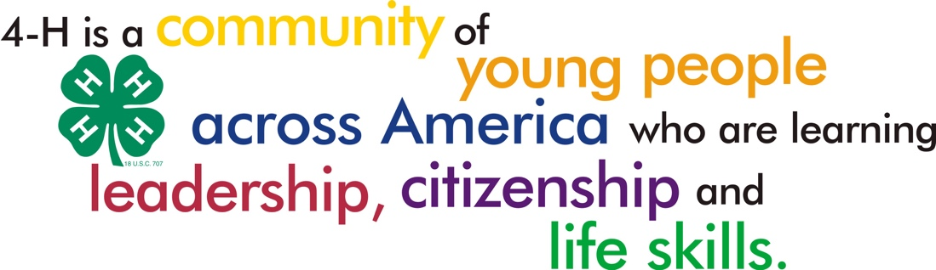

**STATE 4**-**H CONGRESS GENERAL INFORMATION**

INSURANCE—Every registered 4-H member and adult registered volunteer attending State 4-H Congress will be covered with medical insurance. PRE–EXISTING CONDITIONS ARE NOT COVERED. Medical attention for minor and ordinary ailments will be available at the MSU Student Health Center (Phone: 662-325-2431) and after 5:00 p.m. at the Oktibbeha County Hospital (Phone: 662-324-4565).

**ALL medical emergencies MUST BE REPORTED TO THE STATE 4**-**H Department OFFICE, BOST EXTENSION CENTER ROOM 402 (662-325-3350). AFTER HOURS, CALL Dr. Threadgill at 662-312-0615 or Larry Alexander at 662-418-0350.**

The State 4-H Department will not assume responsibility for expenses not covered by this insurance.

4-H PARENTAL RELEASE AND CODE OF CONDUCT AGREEMENT (F807)

Each 4-H member must have two (2) Form 807 ─ 4-H Parental Release and Code of Conduct Agreement Forms signed by a parent or guardian and the 4-H member. The agent must keep one (1) copy and the second copy must be turned in at check in. A copy of this form is included in this handbook. This form is also available through the MSU-ES Publication Ordering system or printed from the Extension website:

<http://extension.msstate.edu/sites/default/files/publications/forms/f0807_0.pdf>

**DO NOT MAIL/SEND 4**-**H Parental Release, Code of Conduct Agreement or Swim Release forms to the State 4**-**H Office! BRING THEM WITH YOU TO STATE 4**-**H CONGRESS AND TURN THEM IN AT CHECK IN on the first day.**

**4**-**H HEALTH & MEDICAL EMERGENCY FORM (F696)**

To receive treatment at the Longest Student Health Center (MSU) and/or Oktibbeha County Hospital, you must have Form 696, Mississippi 4-H Health & Medical Emergency Form for each 4-H’er and adult. Each 4-H member and adult certified volunteer leader must complete two (2) copies. The agent must keep one (1) copy and the second copy must be turned in at check in. A copy of this form is included in this handbook. This form is also available through the MSU-ES Publication Ordering system or printed from the Extensionwebsite:

[**http://extension.msstate.edu/sites/default/files/publications/forms/f0696.pdf**](http://extension.msstate.edu/sites/default/files/publications/forms/f0696.pdf)

**DO NOT MAIL/SEND Mississippi 4**-**H Health & Medical Emergency Form HEALTH CARD FORMS WITH REGISTRATION. FORMS MUST BE TURNED in at State 4**-**H Congress check in.**

In case of an emergency, call the State 4-H Department at 662-325-3350 during normal working hours (8:00 am–5:00 pm). After 5:00 pm and before 8:00 am, call MSU Police at 662-325-2121. In case of serious illness or accident, notify the delegate’s parents immediately.

COUNTY BOXES

All messages will be placed in county boxes in Room 401 of the Bost Extension Center. Contest Ribbons will also be placed in the county boxes after the contests. Results will also be provided through the 4-H Congress App.

Contest winners will be announced on the television monitors in Bost Building A and Bost Building B. and via social media outlets.



**WHAT IS EXPECTED OF EACH DELEGATE**

**2019 STATE 4-H CONGRESS APPROPRIATE DRESS**

Promote a positive image of 4-H by encouraging your delegates to wear clothing that will identify them as successful young people. **All delegates (youth and adults) are always required to wear name tags.** The chart below will help you know what is appropriate for each activity during State 4-H Congress. Appropriate dress is critical because we always want to make a positive impression for 4-H. Green and white clothing or display of 4-H emblem on clothing is encouraged at all functions.

**Note:** Delegates who are not dressed appropriately will be sent back to the dorm with their agent or chaperone to change into appropriate clothing.

|  |  |  |
| --- | --- | --- |
|  | **ACTIVITY** | **APPROPRIATE DRESS** |
| Wednesday | Lunch | Casual |
| Wednesday | Youth Delegate Orientation | Dress appropriate for your competition/workshop - professional or snappy casual |
| Wednesday | Contests/Workshops | Dress appropriate for your competition/workshop - professional or snappy casual |
| Wednesday | Evening Assembly | Casual - *Candidates for State 4-H Council offices should be professionally dressed for their speeches* |
| Thursday | Contests/Workshops | Dress appropriate for your competition/workshop professional or snappy casual |
| Thursday | Dinner, Assembly, and Dance/Optional Activities | Casual with Congress T-shirt |
| Friday | Closing Assembly | Snappy Casual/Professional |

**Casual:** Jeans, khakis, T-shirts, tennis shoes.

**Snappy Casual: Girls –** skirts or slacks with an appropriate blouse or shirt and shoes.

**Guys –** slacks, shirts without ties, and shoes.

**Professional: Girls –** school dress, pantsuit, suit, dress slacks with coordinating top, leather shoes.

**Guys –** dress slacks with a shirt and tie, sports coat if available. No denim clothing or tennis shoes.

**PLEASE DO NOT WEAR:**

* **Any** clothing with inappropriate or unsuitable graphics or slogans.
* Tube tops, halter tops, one-shoulder tops, strapless tops, casual tops with spaghetti straps, dresses/tops/ pants/skirts that expose midriff, navel, back, or cleavage.
* See-through or muscle shirts.
* Clothing that advertises alcoholic beverages, tobacco products, or drugs.
* Clothing that has vulgar, obscene, or offensive messages or images.
* Cut-offs, ripped jeans, or other clothing with holes.
* **NOTE: When in doubt about attire, 4-H’ers should check with their County Extension Agent.**

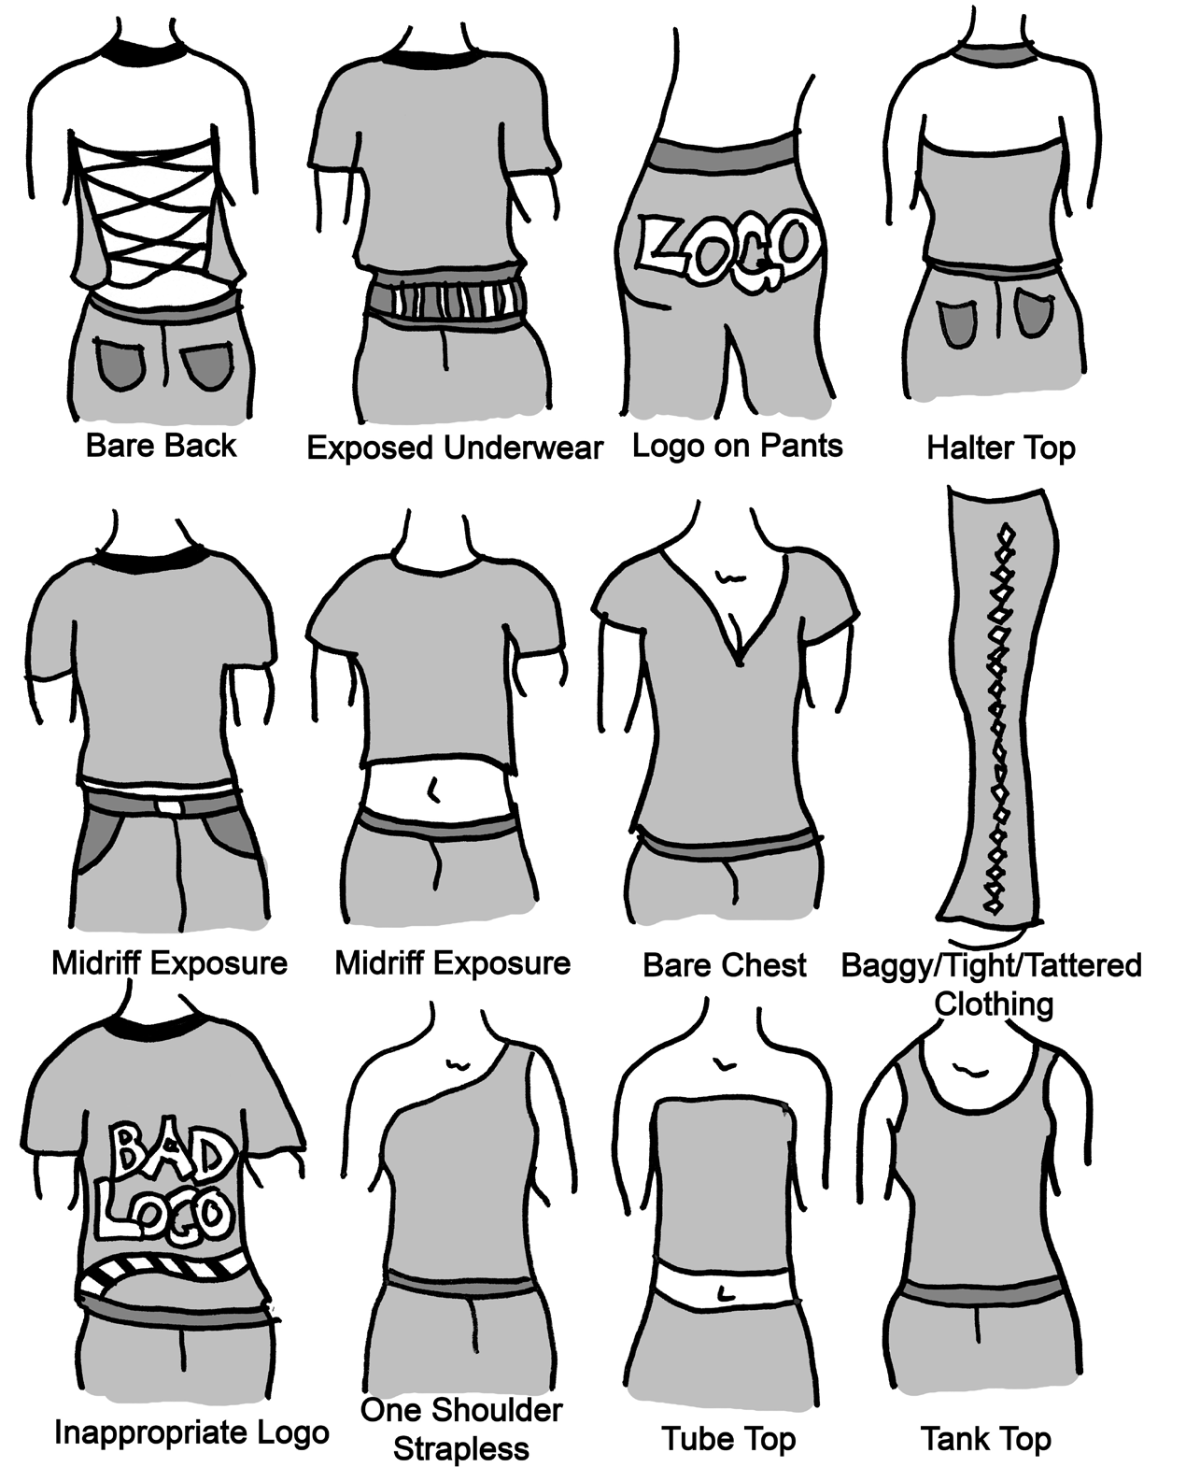

**WHAT TO PACK FOR 4-H CONGRESS**

Following is a general list of items to pack when living away from home in a campus residence hall.

Personal Clothing

* appropriate clothes for contest and/or workshops and other activities
* shoes, socks, etc.
* sleepwear, undergarments

**Bed Linens**

* linens (sheets) or sleeping bag
* pillow
* blanket

**Personal Care**

* towel, washcloth
* hair care (shampoo, styling gel, brush/comb, etc.)
* toiletries such as soap, deodorant, lotion, sunscreen, q–tips, etc.
* teeth care such as toothpaste, toothbrush, dental floss, mouthwash, etc.
* shower shoes/flip flops

## Contest Equipment

* visual presentation (posters, jump drive, supplies, etc.)
* plastic garbage bag for protection in case of rain
* workshop supplies (if needed)/contest supplies, pencils, clipboard, etc.
* contest release forms, if applicable (i.e., automotive driving, tractor driving, etc.)

## Optional Items

* camera
* flashlight with new batteries
* medication
* personal first aid kit (band aids, antibacterial ointment, mosquito bite itch relief cream, etc.)
* small sewing kit
* umbrella or rain gear

### 2019 CAMPAIGNING & ELECTION GUIDELINES

**CAMPAIGNING**

* “Meet Your Candidates” campaigning is restricted to the following times and location Wednesday**, May 29, 2019** 12:30 pm until 1:15 pm in front of Bost Building B and from 7:00 pm until 7:30 pm in front of Bost Building B. At these times, candidates will be available to shake hands, hand out campaign literature, and talk about their candidacy with voters.
* Each candidate may present only one poster no larger than 22” x 28” at the “Meet Your Candidates” event at 12:30 pm – 1:15 pm in front of Bost Building B on Wednesday, **May 29, 2019**.
* The poster may be placed on an easel or stand brought by the candidate. Candidates must remove their posters and clean up all trash by 7:00 pm, Wednesday, **May 29, 2019**.
* Candidates cannot post anything on the inside or outside of the residence halls. The only place a candidate can post anything is on their individual residence hall door.
* Candidates cannot post anything on the inside or outside of Bost Extension Facilities.
* Candidates can put items on an easel or a table.
* Candidates are to clean up after all any campaigning (pick up all trash on the grounds inside and outside).
* Candidates should run on their own merits. Distasteful or negative comments (put-downs) about another candidate, whether implied or stated, are unacceptable and could result in disqualification. Candidates will be disqualified if they throw items into the audience from the stage.
* All campaigning will be at the expense of the campaigner.
* Campaigning may not be done in the area of the polls. Candidates will be disqualified if they campaign during the voting process.

**Campaign Speeches**

* Campaign Speeches will be presented during the General Assembly the night of Wednesday, **May 29, 2019** in the Bost Building B Auditorium. Candidates should arrive 15 minutes prior to the start of the assembly (7:15 pm) to be seated in the reserve section.
* All candidates (excluding the Song Leader) will deliver a prepared speech at the Wednesday night at the General Assembly. Song Leader candidates can do a speech, rap, sing, or chant, and they can get audience participation.

**Professional business attire is required**

Guys: Dress slacks and shirt with tie; jacket is optional.

Girls: Business suit (pants or skirt) or dress.

**Speeches**

**Candidates for President** **– 3 minutes**

* + Speeches should be professional in nature with NO theatrics, props (hats, wigs, shoes, wheels, etc.), extra people, audience distractions, and loud noises or yelling.

**Candidates for Vice President, Secretary, Parliamentarian, Reporter, and the Regional Vice Presidents – 2 minutes**

* + Speeches should be professional in nature with NO theatrics, props (hats, wigs, shoes, wheels, etc.), extra people, audience distractions, and loud noises or yelling.

**Candidates for Song Leader – 3 minutes**

* + Can lead and teach the audience a song, rap, or chant.
  + Audience participation is welcomed and strongly encouraged.
    1. Speeches, song, rap, or chant should be professional, respectful, and centered around 4-H.
    2. Candidates’ campaign staff can give out song, rap or chant prior to the program.

**ELECTION**

Voting will be held Wednesday evening following the General Assembly in Bost Building A Lobby and Bost Building B. If a runoff is necessary, it will be at the Thursday evening General Assembly in Bost Building B. Voting will be done electronically.

**The voting process**

* 4-H’ers will vote by region.
* Each Region will have an election commissioner manning the tables and electronic device.
* Delegates will sign-in with the “election commissioner.”
* Delegates will electronically submit their vote.

**General Information**

* Election results are announced on Thursday night, **May 30, 2019** during General Assembly in the Bost Building B.
* An orientation meeting and installation practice for all newly elected officers will be held on Friday**, May 31, 2019** at 8:00 am at the stage in the Bost Building B Auditorium.
* Pictures of the newly elected State 4-H Council Officers are taken following the awards program on Friday morning.

**4-H Congress SERVICE-LEARNING Project**

Locations affected by inclement weather will be the focus of the service-learning project.

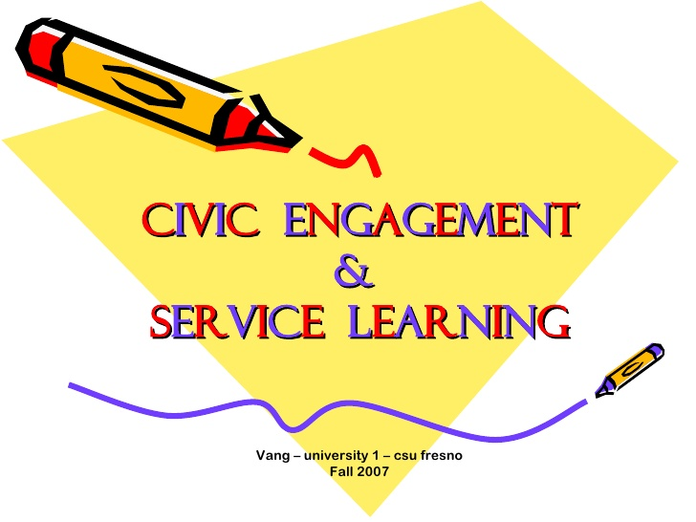

MSU Extension 4-H

**SHARE THE FUN**

**General Rules**

The 4-H Share-the-Fun program is designed to give 4-H members opportunities to express themselves through the performing arts.

1. Participants must be enrolled in a 4-H club or as an individual member.
2. Each county may enter three acts. The three acts may be all individuals or all groups or any combination of individuals and groups. A participant may enter as an individual and as a member of a group.
3. Group act participants must schedule their participation in other events so that all group members will be available to perform at the same time. Participants selected to perform at the State Congress 4-H Talent event will not necessarily include the performance group or number in its original form.
4. Previous participants in Share-the-Fun are eligible to participate.
5. Individual and group acts should be 3 to 5 minutes in length. Judges will penalize acts over 5 minutes.
6. Individual acts may have one accompanist.
7. Acts with knives, fire and other potential safety hazards will not be allowed.
8. Acts requiring more than 5 minutes to set up must schedule their performance with the show coordinator. (Bands in particular!)
9. Tape player and CD player will be provided.

**Senior Rules (14–18)**

1. Acts for the State Share the Fun event must be pre-registered by submitting a registration form one month prior to the state contest. Specific due dates for these forms will be on the registration form.
2. At the event, acts will perform for competition based on a pre-arranged schedule. Participants will be notified about the time of their performance. This should allow these participants the opportunity to be involved in other state contests and activities.
3. Participants will have the opportunity to request a preferred time and all reasonable effort will be made to accommodate the requests.
4. Senior acts will be divided into five divisions. These divisions are as follows: Vocal, Drama, Instrumental, Dance, and Combination acts.
5. Premiere performers will be selected to perform in the Share-the-Fun Show Thursday night.
6. Individual and group acts may be selected to perform during the year at 4-H Volunteer Leaders’ Programs and other 4-H and/or Extension related events. Selections will be at the discretion of the person in charge of an event based on the nature of the acts.

**Refer to the 4**-**H Awards and Recognition Handbook, pages 68–72.**

**County Delegations Night Out**

**WHEN:** Wednesday, **May 29, 2019 (Immediately after voting)**

**WHERE:**  Starkville/Columbus Vicinities

**WHAT:** Fun and good food

**Starkville MS**

* Bin 612 – 612 University Dr., Starkville 662-324-6126
* Mugshots Grill – 550 Russell Street, Starkville 662-3243965
* McAlister’s Deli – 500 Russell Street, Starkville 662-3242565
* Harvey’s Restaurant – 406 Hwy 12 East, Starkville 662-323-1639
* Hungry Howie’s Pizza – 87 Carol Cotton Lane, Starkville 662-270-5355
* Buffalo Wild Wings – 703 Spring Street, Starkville, 662-324-4494
* The Little Dooey – 100 Fellowship Street, Starkville 662-323-6094
* Central Station Grill – 2000 South Montgomery Street, Starkville 662-323-6062
* Slim Chickens – 519 S. Montgomery Street, Starkville 662-268-8203
* Umi Japanese Steakhouse – 315 Hwy 12 West, Starkville 662-323-5258

**Columbus, MS**

* Huck's Place – 121 5th Street South, Columbus 662-327-6500
* Harvey’s – 200 Main Street, Columbus 662-327-1639
* The Little Dooey – 701 Hwy 45 North, Columbus 662-327-0088
* Mi Hacienda – 1207 Hwy 45 North, Columbus 662-327-3396
* Cracker Barrel Old Country Store – 592 18th Street North, Columbus 662-243-7615
* Long Horn Steakhouse – 2023 Hwy. 45 North, Columbus 662-244-8485
* Umi Japanese Steakhouse – 1721 Hwy 45 North, Columbus 662-570-4769
* Buffalo Wild Wings – 2001 Hwy 45 North, Columbus 662-245-1171
* Mugshots Grill – 1737 Hwy 45 North, Columbus 662-798-0879
* Logan’s Roadhouse – 589 18th Avenue North, Columbus 662-329-1117

**Fun in Both Starkville and Columbus**

* Malco Theatre – 2320 Hwy 45 North, Columbus 662-240-4171
* GT Bowling Lanes – 1207 Hwy 45 North, Columbus 662-359-6933
  + ***Bowling, Laser Tag, Arcade, Bouncing Bash, and great food***
* Hollywood Premier Cinemas – 101 Hollywood Blvd, Starkville 662-320-9000
* Skate Odyssey – 830 Louisville Street, Starkville 662-323-8821

**NOTE: Those counties planning to go out should call the restaurant or venue ahead of time just to alert them you are coming.**

SIMPLE COURTESIES

***While in Assemblies***

* Arrive on time for all assemblies, take your seat in the designated area, and stay in your seat until the assembly adjourns. Turn off electronic devices, mute cell phones, and refrain from text messaging.
* Arrive on time for all workshops and participate fully in the sessions.
* Do not take food or drinks into assemblies or workshops.
* Give the speaker/presenter your undivided attention.
* Treat assembly speakers with respect. Think about how you would want to be treated if you were on the stage. Stay in your seat, applaud at appropriate times, and listen.
* Do not congregate at entrances or stage areas.
* All agents/volunteers/program assistants must maintain order during all assemblies, and meetings, not only for their county delegation, but for every 4-H’er.

##### While in Your Residence Hall

* You will live in the room assigned to you at registration.
* Do not move furniture from one room to another.
* You will be financially responsible for damage to your room. The damages will be assessed, and the county will be sent a bill, but the individuals assigned to the room will be billed by the county in order to pay for these damages.
* We may share residence hall space with other groups and students with very different schedules. Talk quietly in residence halls and rooms and avoid any conduct that may annoy others.
* Keep your room neat and orderly at all times.
* Make your own bed each morning!!!
* For your privacy, window shades should be drawn when lights are on in the rooms.
* Care for your valuables.
* Keep the restrooms clean.
* In case of disturbance in the residence hall, report to your Extension agent or adult volunteer leader.
* Be in your own room at the hour set as curfew. Observe “lights out” at designated times. Delegates are not allowed out of the residence hall room past curfew unless an agent is with them. This means: no pizza runs, phone calls, drink machines, etc.
* DO NOT throw anything out of residence hall windows or from balconies, or tamper with smoke alarms. These are very serious safety violations which can result in expulsion from campus.
* Keep your room door locked. Keep your room access card with you at all times. If you lose it you will be charged $15. Payment is due prior to leaving State 4-H Congress!
* DO NOT remove window screens. Violators will be billed for a replacement(s).
* No girls in boys’ rooms. No boys in girls’ rooms. You may visit in the lobby of the residence halls before curfew.
* Signs (campaign or any others) may only be posted on individual doors to rooms and nowhere else in the residence hall.
* DO NOT leave trash in rooms! Discard all trash before checking out of your room. **(Counties will be assessed a cleaning fee of $75 if trash is left in the resident rooms)**

**CHARACTER COUNTS! Guide for Behavior**

***When You Are on Campus***

* Smoking is not permitted**. (No smoking of any kind or use of any tobacco will be allowed.)**
* As always at 4-H events, no alcohol or other drugs are allowed. Violators will be referred to their Extension agent and/or parents. All delegates will be required to abide by the 4-H General Rules and Release (Code of Conduct for4-H Events) found in Form 807 which you signed prior to leaving your home.
* Permission to leave campus may be granted only for emergencies.
* Respect university property as if it were your own.
* Campaign litter must be picked up and put in trash cans.



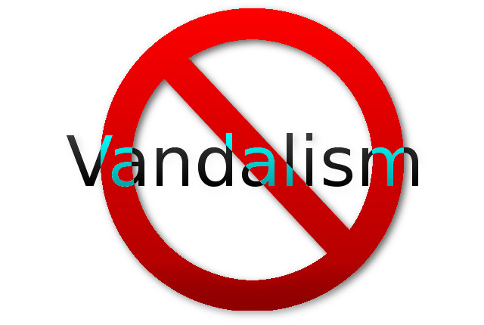No-e-cigs-detail

**Respect**

* Treat everyone with respect by being polite.
* Respect the individuality of others.
* Be accepting of individual differences.
* Judge people on their merit, not on their race, religion, nationality, gender, physical or mental condition, social or economic status, or any other improper factor.

**Caring**

* Show you care about others through kindness, caring, generosity, and compassion.
* Live by the “GOLDEN RULE” . . . treating others the way you want them to treat you.
* Think what every decision, word, or action will do to other people.

**Trustworthiness**

* ***Honesty***—be open and direct, be sincere, return things you find
* ***Promise-keeping***—keep your word, make only promises you plan to keep, return what you borrow, be someone others can trust
* ***Loyalty***—keep private information private and stand up for, support, and protect your family, friends, teachers, employers, school, community, and country
* ***Integrity***—stand up for your beliefs – right and wrong, say no to social pressure on things you think are wrong, and have courage to do the right thing – “walk your talk”

**Responsibility**

* Be accountable, use self-restraint, and pursue excellence.
* Think before you act.
* Consider the consequences on yourself and others.
* Accept responsibility for your actions or lack of action.
* Be reliable and always perform your duties.
* Set a good example in what you say and do.
* Take the initiative to make your school, organization, neighborhood, or home better for yourself and others.
* Do your best and make everything you do worthy of your pride.
* Stick to it and meet your responsibilities even when it is difficult to do.
* Keep a calendar of things-to-do notes.
* Finish your work before you play.

**Fairness**

* Be fair to everyone.
* Listen to others—try to understand what they feel and say.
* Use the same rules for everyone.
* Correct your mistakes.
* Think before you decide.

**Citizenship**

* Obey the laws and rules, at home, at school, and wherever you are
* Do your share, stay informed, vote, protect your family and community, report crime and wrong-doing
* Be charitable and altruistic

**Wednesday, May 29, 2019**

###### 2019 STATE 4-H CONGRESS

###### TENTATIVE AGENDA

**THEME: 4-H: Our Future Is So Bright, We Gotta Wear Shades**

8:30 am — 11:30 am Registration of County Delegations (**Adults Only)** TBA

9:00 am — 1:30 pm Share the Fun Bost Bldg. B Auditorium

Welding Contest Ag Engineering

PowerPoint Contest Bost Building B Theater

10:00 am — 10:30 am Officer Candidates Meeting TBA

11:00 am — 12:30 pm Lunch (on your own)

12:45 pm — 1:15 pm Adult orientation meeting at Bost Bldg. B

Informal campaigning in front of Bost Building

1:15 pm — 1:45 pm General Assembly

Welcome to MSU

2:00 pm — 4:30 pm Visual Presentation Contest

2:00 pm — 4:30 pm Workshops/Tours

4:00 pm — 5:00 pm Informal campaigning in front of Bost Building B

5:15 pm — General Assembly Bost Bldg. B Auditorium

Speaker

State 4-H Congress Political Rally–State and Region Candidate Speeches

Election Committee Meeting Bost Bldg. B. Theater

After Assembly Voting by Regions Bost Bldg. B

4-H Evening Out

County meetings

11:30 pm Lights Out

**Thursday, May 30, 2019**

7:00 am — 8:00 am Breakfast (on your own)

8:00 am — 12:00 pm State 4-H Ambassador and National 4-H Conference Interviews

8:45 am Report to Morning and All–day Contests/Workshops

9:00 am — 5:00 pm All-day Contests

9:15 am — 12:00 pm Morning Contests

9:30 am — 12:00 pm Morning Workshops

11:00 am — 1:00 pm Lunch (on your own)

1:00 pm — 5:00 pm State 4-H Ambassador and National Conference Interviews

1:15 pm Report to Afternoon Contests/Workshops

1:30 pm — 5:00 pm Afternoon Contests

Afternoon Workshops

Share-the-Fun Sound Check/Practice

5:30 pm — 6:30 pm Dinner (on your own)

7:00 pm — 9:00 pm General Assembly in Bost Bldg. B Auditorium

Share the Fun Show and Modeling Squad Showdown

Election Runoff, if needed

9:00 pm — 11:30 pm Dance in the Union Ballroom/Games in the Union Dawg House

11:30 pm — 12:00 am County Meetings – County Staff

12:30 am Lights Out

**Friday, May 31, 2019**

7:00 am — 8:30 am Breakfast (on your own)

7:00 am — 9:00 am Residence Hall check-out and access cards return

8:00 am — 8:45 am Practice for Officer Installation on Stage in Bost Bldg. B Auditorium

First Place Winners report for seating

9:00 am — 11:00 am General Assembly in Bost Bldg. B Auditorium

Installation of State 4-H Council Officers

Awards and Recognition

Announce 2019–2020 State 4-H Ambassadors

Announce 2020 National 4-H Conference Delegates

Announcements

Adjourn with 4-H Pledge

11:00 am — 11:30 am Orientation & Photo Session in Bost Bldg. B Auditorium

2019–2020 State 4-H Ambassadors

2020 National 4-H Conference Delegates

2019–2020 State 4-H Council Officers

## WEDNESDAY, May 29, 2019

**9:00 AM – 2:00 PM**

COMPETITIVE ACTIVITIES

— 4-H Dairy Poster / *Jousan* *(Junior and Senior)*

— Poster Art / *Alexander* *(Junior and Senior)*

— Insect Collection / *Guyton (Senior Only)*

— Photography Exhibits / *Ag Comm*

— Share-the-Fun */ State Staff*

— PowerPoint Presentations *(by appointment) / Morgan*

— Welding Contest / *Ward*

**All exhibit entries**

**must be turned in prior to 11:30 am**

**THURSDAY, May 30, 2019**

**9:15 am – 12:00 noon, Continued**

— Consumer Judging / *Smith*

— Dairy Products Judging / *Jousan*

— Entomology Insect ID and Collection / *Guyton*

— Forestry Judging* / *Forestry Dept*

— Horticulture Judging / *Denny*

— Interior Design / *State Staff*

— Meats Judging* / *Jousan*

— MS 4-H Cookoff / *Fountain*

* Photography / *Hudson*

— Poultry Egg Preparation / *Wells*

— Public Speaking, I & II / *State Staff*

— Tractor Driving* / *Wooten*

* Wildlife Judging / Burger

\**Since these contests may last longer than the time allotted, a 4-H’er entering these contests will not be allowed to compete in a PM contest. These 4-H’ers should plan to go to a Thursday afternoon workshop when finished with these contests.*

**WEDNESDAY, May 29, 2019**

**2:00 PM – 4:30 PM**

VISUAL PRESENTATION CONTESTS

— Beef / *Jousan*

— Clothing */ FCS*

— Conservation *(Forestry, Wildlife, Soil, and Water)*  / *Burger*

— Consumer Education / *Smith*

— Dairy Animals; Dairy Foods / *Jousan*

— Engineering *(Bicycle, Safety, Petroleum Power)*

*/ Wooten*

— Entomology / *Guyton*

— Foods and Nutrition *(includes Preservation)/ Fountain*

— Gardening; Horticulture / *Denny*

— Health / *Buys*

— Modeling Squad Showdown / *Kobia*

— Other Projects *(any project with no contest)*/ *State Staff*

— Photography (*Pre-registration required)* **/** *Ag Comm*

— Plant and Soil Science / *Reginelli*

— Sheep; Swine; Meat Goats / *Jousan*

— Vet Science and Pet Care / *State Staff*

**THURSDAY, May 30, 2019**

**1:00 pm – 5:00 pm**

✯State 4-H Ambassador/National

4-H Conference Interviews

**2:00 pm – 5:00 pm**

AFTERNOON CONTESTS

* Child Development
* Citizenship Bowl
* Clothing Construction / *FCS*

— Compact Tractor / *Linhoss*

— Dairy Bowl / *Jousan*

*—* Electric Judging / *Wooten*

— Livestock Bowl / *Jousan*

— Poultry Judging / *Wells*

— Robotics / *Morgan*

* Seed ID & Quality / *Reginelli*

— Small Engines / *Wooten*

**FRIDAY, May 31, 2019**

**9:00 am – 11:00 am**

Bost Bldg. B. AUDITORIUM

Awards & Recognition Program

**THURSDAY, May 30, 2019**

**9:15 am – 12:00 noon**

MORNING CONTESTS

— Automotive Driving* / Tagert

— Bicycle* / *Alexander*

— Career Pursuit / *Swortzel*

— Clothing Selection / *FCS*

— Computer / *Morgan*

### Contest Schedule





**M2204** (03-19)

*Mississippi State University is an equal opportunity institution. Discrimination in university employment, programs, or activities based on race, color, ethnicity, sex, pregnancy, religion, national origin, disability, age, sexual orientation, genetic information, status as a U.S. veteran, or any other status protected by applicable law is prohibited. Questions about equal opportunity programs or compliance should be directed to the Office of Compliance and Integrity, 56 Morgan Avenue, P.O. 6044, Mississippi State, MS 39762, (662) 325-5839.*

*For disability accommodation, please contact* ***[name of contact person]*** *at* ***[phone number and/or email address]****.*

Extension Service of Mississippi State University, cooperating with U.S. Department of Agriculture. Published in furtherance of Acts of Congress, May 8 and June 30, 1914. GARY B. JACKSON, Director